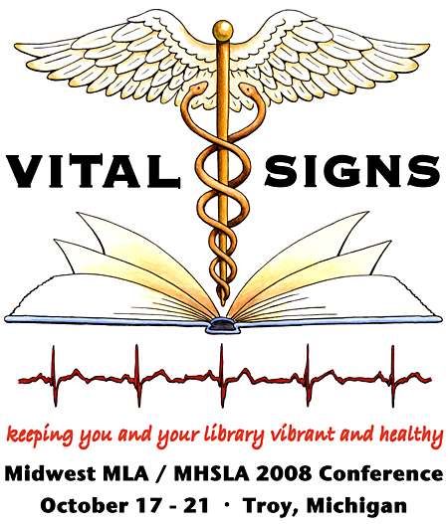

April 25, 2008
Report - 2008 Conference Planning Committee
For the joint Michigan Health Science Libraries Association and
Midwest Chapter / Medical Library Association Conference

The 2008 conference will be a joint conference of the Michigan Health Sciences Libraries Association (MHSLA) and the Midwest Chapter / Medical Library Association. The Metropolitan Detroit Medical Library Group (MDMLG) will be the hosting group. Committees have been appointed and a date and site have been chosen. The conference will be held October 17-21, 2008 and at the Detroit Marriott – Troy and the theme will be “Vital Signs: Keeping You and Your Library Vibrant and Healthy”. The planning committee has been meeting on a bi-monthly basis, alternating between the Detroit area and Lansing.

Significant accomplishments to date include:
- A preliminary budget was submitted to all three organizations in January and has been updated throughout the year.
- A site for the special event has been identified (Detroit Institute of Arts) and reserved, pending finalization after the completion of the DIA renovation. There will be a welcome reception at the Marriott featuring some Michigan foods and beverages
- The Education Committee has a completed schedule for CE and programming and speakers and instructors have been contracted. The keynote speaker has been confirmed and will be Dina Ebert from the “Fish Leadership” organization. The Plenary speaker will be Eugenie Prime.
- Ten CE opportunities are currently planned as well as contributed paper and poster sessions.
- A poster was created for publicity at the 2007 MHSLA and Midwest meetings. Publicity also has giveaways and trinkets to distribute. A “save the date” postcard for the conference was mailed out in February.
- A logo was designed and is available for downloading on the conference planning website and wiki.
- A conference planning website and listserve were developed. Meeting minutes, planning documents, budgets and the roster were posted for use by committee members. A conference planning wiki and general conference blog and wiki have also been developed. All planning website information has been transferred to the planning wiki, and the committee will be using the wiki going forward.
- There are 15 confirmed exhibitors as of April 2008, and many more have been contacted.
- Options for online registration have been identified.
- Preliminary meeting room assignments have been made and will be finalized with the Marriott.
- Several planning committee members attended the 2007 Midwest Conference in Omaha in October to gather additional planning tips and information.
- The public conference website is now up on the web at: http://midwestmla2008.blogspot.com
- Items on the website include “Program at a Glance”, information about the keynote speakers, information about the special events, information about transportation options, a list of committed exhibitors and hotel information.
- Registration information should be up on the website by the end of May or early June.

Submitted by:
Ellen O’Donnell, Conference Coordinator and Finance Chair
Sandra Martin, Local Arrangements Chair

